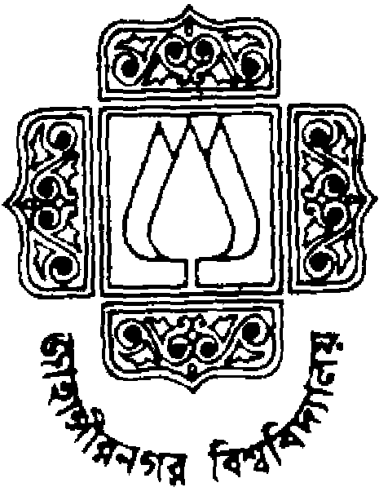 |  | Jahangirnagar University  Institute of Information and Technology  Course Title: Differential and Integral Calculus  Assignment No.: 3
1 | Integrate the following:
(i) 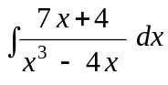; (ii) 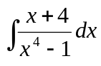; (iii)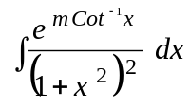; (iv) 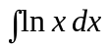;
(v) ; (vi) 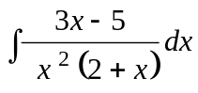; (vii)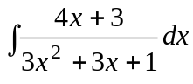; (viii) 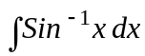.
2 | Prove that 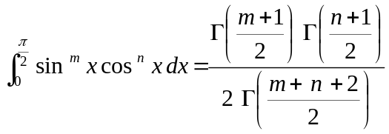. Hence evaluate 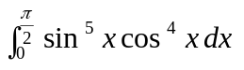.
3 | (a)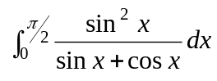; (b)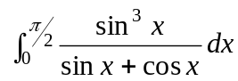; (iii)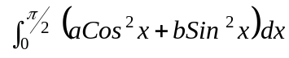.
4 | Find the area of the region enclosed by the curves 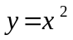 and 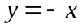 by integrating with respect to x and also with respect to.
5 | Find the area of the region enclosed by the curves and 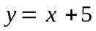 .
6 | Consider the astroid 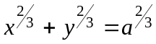, 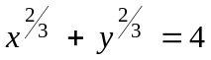, 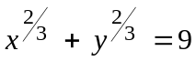. Determine the whole length and area of the above astroid. Also find the surface area and volume of the spindle shape solid generated by revolving this astroid about -axis.
7 | Find the volume of the solid generated when the region between the graphs of 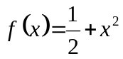 and 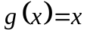 over the interval 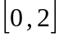 is revolved about the X-axis.

